DAY 1 Monday

Linux Basics and CentOS Administration

**Network Administration**

[Type of Files in Linux](https://www.cherryservers.com/blog/a-complete-guide-to-understanding-linux-file-system-tree" \l "type-of-files-in-linux)

* [/ ( Root Directory)](https://www.cherryservers.com/blog/a-complete-guide-to-understanding-linux-file-system-tree" \l "--root-directory)
* [/home](https://www.cherryservers.com/blog/a-complete-guide-to-understanding-linux-file-system-tree" \l "home)
* [/root](https://www.cherryservers.com/blog/a-complete-guide-to-understanding-linux-file-system-tree" \l "root)
* [/boot](https://www.cherryservers.com/blog/a-complete-guide-to-understanding-linux-file-system-tree" \l "boot)
* [/bin](https://www.cherryservers.com/blog/a-complete-guide-to-understanding-linux-file-system-tree" \l "bin)
* [/sbin](https://www.cherryservers.com/blog/a-complete-guide-to-understanding-linux-file-system-tree" \l "sbin)
* [/dev](https://www.cherryservers.com/blog/a-complete-guide-to-understanding-linux-file-system-tree" \l "dev)
* [/etc](https://www.cherryservers.com/blog/a-complete-guide-to-understanding-linux-file-system-tree" \l "etc)
* [/media](https://www.cherryservers.com/blog/a-complete-guide-to-understanding-linux-file-system-tree" \l "media)
* [/mnt](https://www.cherryservers.com/blog/a-complete-guide-to-understanding-linux-file-system-tree" \l "mnt)
* [/tmp](https://www.cherryservers.com/blog/a-complete-guide-to-understanding-linux-file-system-tree" \l "tmp)
* [/opt](https://www.cherryservers.com/blog/a-complete-guide-to-understanding-linux-file-system-tree" \l "opt)
* [/var](https://www.cherryservers.com/blog/a-complete-guide-to-understanding-linux-file-system-tree" \l "var)
* [/run](https://www.cherryservers.com/blog/a-complete-guide-to-understanding-linux-file-system-tree" \l "run)
* [/proc](https://www.cherryservers.com/blog/a-complete-guide-to-understanding-linux-file-system-tree" \l "proc)
* [/usr](https://www.cherryservers.com/blog/a-complete-guide-to-understanding-linux-file-system-tree" \l "usr)

File system:-

A file system is the methods and the data structures that an operating system uses to keep track of files.

Told about VI editor

Vi files.txt

Click on i to get into insert mode

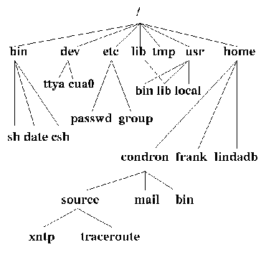

Useradd Luffy

Passwd Luffy

Exit

Touch files.txt

Cat>>mkt.txt

Cat mkt.txt

Touch { 1,2,3 …. 10}

ls

touch { 5.6.6 … 10}

ls

touch 12 13 14 15 16

ls

mkdir a b c d

dir

mkdir -p x>y>z

dir

ls -l

cd x

dir

**ACL**

→setfacl – Set file access control list

- It is use to give multiple user access on one file.

▪ [root@localhost ~]# mount -a acl,remount /

▪ [root@localhost ~]# setfacl -m u:luffy:rwx file1.txt

▪ [root@localhost ~]# setfacl -m u:zoro:r file1.txt

→To check ACL:

▪ [root@localhost ~]# getfacl file3.txt

→To give same ACL to different file:

▪ [root@localhost ~]# getfacl file1.txt | setfacl --set-file=- file2.txt

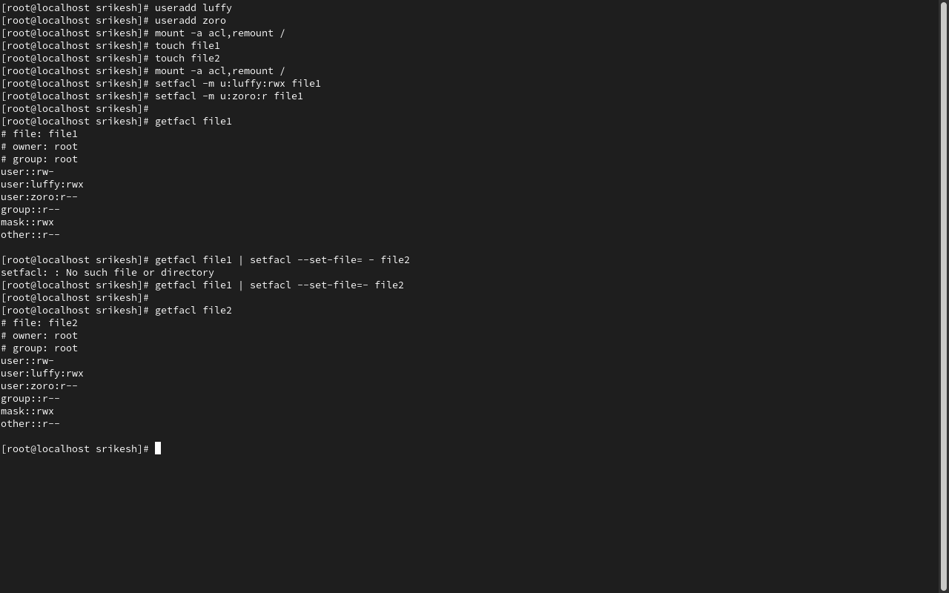

➢ Mount .iso file, install Apache web server and allow that service using firewall.

→Insert .iso file:

o Select ‘Machine’ menu of server.

o Select Storage.

o Inside Controller iDE select Dropdown near Optical drive

o Select ‘Choose a disk file’.

o Select centos .iso file.

o Ok & Apply

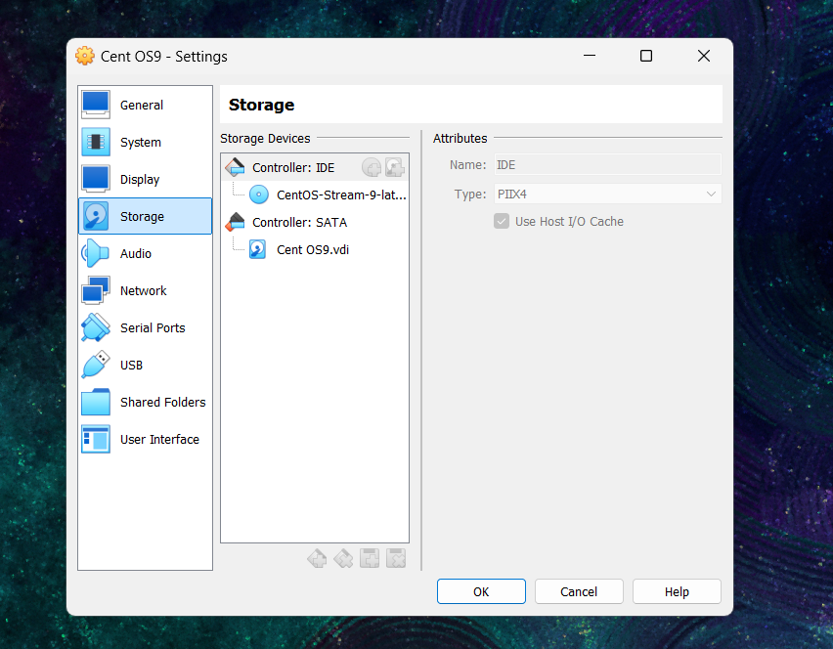

→In CLI of CentOS: [To open: ctl + alt +f2 & close: ctl + alt + f1]

o To Mount:

▪ [root@localhost ~]#mount /dev/sr0 /mnt

▪ [root@localhost ~]#ls -l /mnt

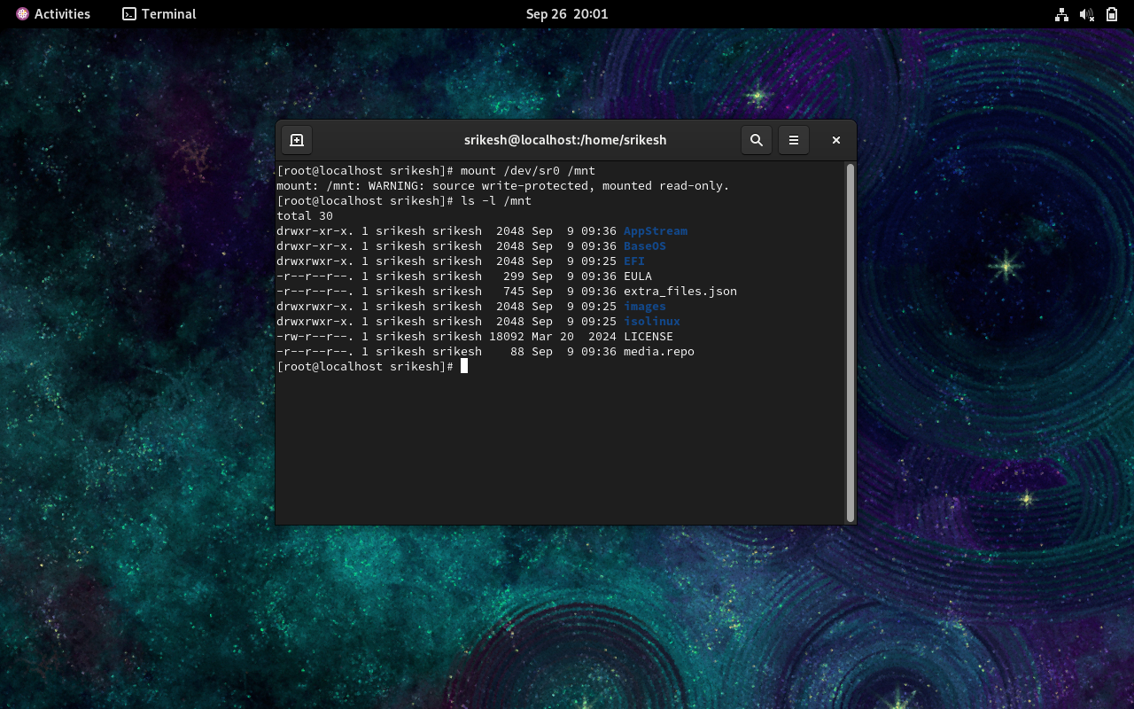

→Open Terminal in CentOS:

o Application => System Tool => Terminal

▪ [root@localhost ~]#cd /etc/yum.repos.d

▪ [root@localhost yum.repos.d]#ls –l

o To remove all .repo files:

▪ [root@localhost yum.repos.d]#rm -f *.repo

o Create new repo file:

▪ [root@localhost yum.repos.d]# vi local.repo

▪ In VI editor, Press ‘i’ to insert and write the below content:

▪ [local.repo] name=centosrepo

baseurl=file:///mnt

enable=1

gpgcheck=1

gpgkey=file://mnt/RPM-GPG-KEY-CentOS-7

▪ To exit: ESC + :wq

▪ [root@localhost yum.repos.d]# yum repolist all

▪ OUTPUT: “enabled:4070

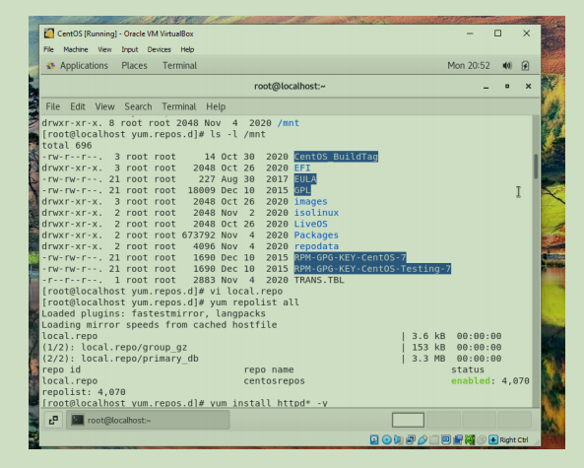

o To install Apache web server:

▪ [root@localhost yum.repos.d]# yum install httpd* -y

▪ OUTPUT: “Complete!”

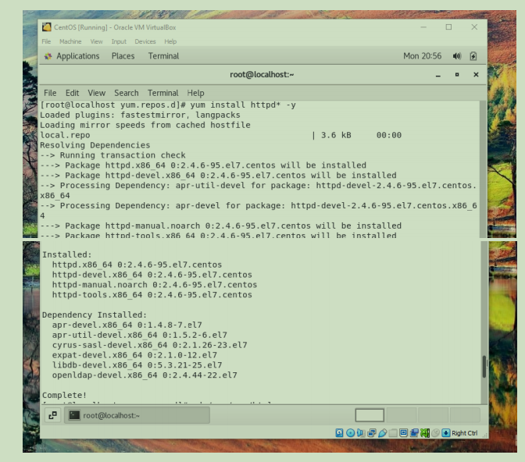

o To confirm it:

▪ [root@localhost yum.repos.d]# cd /var/www/html

▪ [root@localhost yum.repos.d]# cd ~

▪ [root@localhost ~]#